|  |  |
| --- | --- |
|  | **FPT ACADEMY INTERNATIONAL**  **FPT – APTECH COMPUTER EDUCATION** |

**Centre Name: ACE-HCMC-2-FPT.**

**Address: 590 Cach Mang Thang 8, District 3, Ho Chi Minh City, Viet Nam.**

**BidSpirit Online MarketPlace**

|  |  |  |
| --- | --- | --- |
| **Supervisor:** | Ms. Le Mong Thuy | |
| **Semester:** | 1 | |
| **Batch No:** | T1.2403.E0 | |
| **Group No:** | 6 | |
| **Order:** | **Full name** | **Roll No.** |
| 1. | Nguyen Anh Sang | Student1559706 |
| 2. | Truong Nhat Thanh | Student1559703 |
| 3. | Nguyen Ngoc Tran | Student1559718 |
| 4. | Nguyen Ngoc Yen Thanh | Student1559699 |

Month: 6 Year: 2024

**This is to certify that**

**Mr.** Nguyen Anh Sang

**Mr.** Truong Nhat Thanh

**Ms.** Nguyen Ngoc Tran

**Ms.** Nguyen Ngoc Yen Thanh

**have successfully designed & developed:**

eProject: BidSpirit Online MarketPlace

**Submitted by:**

Ms. Le Mong Thuy

**Date of issue:** July 29th 2024

**Authorized Signature:**

# Acknowledgement

It is often said that “Gratitude is the sign of noble souls”. That’s why we devote this chapter to express our deep gratitude towards those who have supported and guided us to accomplish this eProject successfully.

First and foremost, we appreciate the invaluable assistance that our beloved instructor – Ms. Le Mong Thuy, has offered us. Whenever problems come up, she’ll always the one that we can count on for solutions. Moreover, there were moments when our team decided to give up our project, and Ms. Thuy gave us a pep talk to keep us back on the track. Therefore, once again, we truly value your dedication and guidance, Ms. Thuy.

Next, it would have been impossible to carry out and complete this project without the collaboration among our team members. Although we have gone through many obstacles during the project implementation, eventually we gained what we aimed at by our hard work, our strong commitment and of course, our brotherhood.

Finally, thanks to Aptech’s eProject assignment, we had a golden opportunity to apply what we have learnt into reality and gain hands-on experience which is essential for our future career.

**Problem Definition:**

The BidSpirit Online MarketPlace is a comprehensive digital platform designed to facilitate the buying and selling of a wide array of products . Leveraging modern technology, offering a user-friendly interface and secure transaction processes. Here are some key features and highlights of the T6 Online Marketplace:

Key Features

**Wide Product Range:** BidSpirit hosts a vast selection of products, including antiques, fine art, and furnitures. This diversity allows customers to find they need in one place.

**User-Friendly Interface:** The marketplace is designed with a focus on ease of use, featuring intuitive navigation, advanced search options, and personalized recommendations to enhance the shopping experience.

**Secure Transactions:** Security is a top priority for BidSpirit. The platform employs advanced encryption technologies to ensure that all transactions are safe and secure.

**Customer Service:** The marketplace offers excellent customer service, with support teams available to assist users with any issues or inquiries. This ensures a smooth and satisfying shopping experience.

**Mobile Accessibility:** BidSpirit is fully optimized for mobile devices, allowing users to shop conveniently from their smartphones or tablets.

Highlights

**Global Reach:** BidSpirit connects buyers from around the world, providing access to a global market .

**Community Engagement:** The platform fosters a community where users can leave reviews, rate products, and interact with each other, building trust and reliability within the marketplace.

**Innovative Features:** BidSpirit continuously innovates by integrating new technologies such as AI-driven recommendations, virtual try-ons, and augmented reality shopping experiences.

**Overall, the BidSpirit Online Marketplace stands out as a versatile and dynamic.**

**Hardware/ Software Requirements**

1. **For webmaster**

**Hardware**

* Intel Pentium 4 processor or higher
* 1 Gigabytes of RAM or higher

**Software**

* Windows 7 OS or higher
* Adobe Dreamweaver
* HTML5 and Javascript supporting web browsers such as IE, Chrome or Firefox

1. **For web users**

**Hardware**

* Intel Pentium 4 processor or higher
* 512 Megabytes of RAM or higher

**Software**

* Windows XP OS or higher
* HTML5 and Javascript supporting web browsers such as IE, Chrome or Firefox

# Scope of the work (in brief)

After having a completely discussion among members of the team, decision has been made to point out requirements which need to be developed:

1. Homepage will show best-selling product, top-product.
2. Show image of products.
3. Can compare different products
4. Users also can give feedback

**Architecture and design of the system**

Webpage request

**WEB SERVER**

**WEB BROWSER**

Requested Page

**RENDERING ENGINE**

INTERPRETATION

INTERPRETATION

# Diagram of the website

**HOME**

**ANTIQUES**

**ABOUT US**

**FINE ART**

**FURNITURE**

**ABOUT US**

**CONTACT US**

**TASK SHEET REVIEW 1**

|  |  |  |  |  |  |  |  |
| --- | --- | --- | --- | --- | --- | --- | --- |
| **Project Ref. No.:**  **eP/Advertisement** **Portal Management** **System/01** | | **Project Title:** | **Activity Plan** **Prepared** **By:** | **Date of Preparation of Activity Plan:** | | | |
| **Sr.No.** | **Task** | **Actual Start** **Date** | **Actual** **Days** | **Team** **Mate** **Names** | **Status** |
| 1 | Problem definition | BidSpirit Online MarketPlace | Mr.Sang | 21/06/24 | 1 | Mr.Sang | Completed |
| 2 | Analysis of T6 Market requirements about the website | 21/06/24 | 1 | Ms.Tran | Completed |
| 3 | The scope of the word | 24/06/24 | 1 | Ms.Tran | Completed |
| 4 | Architecture and design of the system | 24/06/24 | 1 | Mr.Sang | Completed |
| 5 | Diagram of the website | 24/06/24 | 1 | Ms.Thanh | Completed |
| 6 | Task sheet | 24/06/24 | 1 | Mr.Thanh | Completed |

|  |  |
| --- | --- |
| **Date:** | |
| Signature of Instructor:  **Ms. Le Mong Thuy** | Signature of Team Leader:  **Nguyen Anh Sang** |

# 

# SITE MAP

|  |
| --- |
| **Navigation bar** |
| **Home** |
| **Antiques** |
| **Fine Art** |
| **Furniture** |
| **About Us** |
| **Contact Us** |

Picture

Table

Chair

Pottery

Statue

Wardrobe

# Mock of the website

## Home

|  |
| --- |
| Antiques Product  Navigation bar  Logo    Furniture Product  Fine Art Product  Footer |

## About Us:

|  |
| --- |
| Footer  Navigation bar  Logo  About T6 Online Marketplace  Picture |

## Antiques:

|  |
| --- |
| Navigation bar  Logo  Antique-Image  Footer |

## Fine Art:

|  |
| --- |
| Navigation bar  Logo  Fine Art-Image  Footer |

## Furniture:

|  |
| --- |
| Navigation bar  Logo  Footer  Furniture-Image |

## Contact Us section

|  |
| --- |
| Navigation bar  Logo  Address  Form feed back  Map  Footer |

**TASK SHEET REVIEW 2**

|  |  |  |  |  |  |  |  |
| --- | --- | --- | --- | --- | --- | --- | --- |
| **Project Ref. No.:**  **eP/Advertisement** **Portal Management** **System/01** | | **Project Title:** | **Activity Plan** **Prepared** **By:** | **Date of Preparation of Activity Plan:** | | | |
| **Sr.No.** | **Task** | **Actual Start** **Date** | **Actual** **Days** | **Team** **Mate** **Names** | **Status** |
| 1 | Site map | BidSpirit Online MarketPlace | Sang | 22/06/24 | 1 | Mr.Thanh | Completed |
| 2 | Mock of the Website | 24/06/24 | 1 | Tran | Completed |
| 3 | Tasksheet | 24/06/24 | 1 | Ms.Thanh | Completed |

|  |  |
| --- | --- |
| **Date:** | |
| Signature of Instructor:  **Ms. Le Mong Thuy** | Signature of Team Leader:  **Nguyen Anh Sang** |

**WEBSITE DESCRIPTION**

**Home:**

a) Description:

- This is a website programmed about Alpine Ascents, and here are some detailed guidelines for using the website.

b) Screenshot:

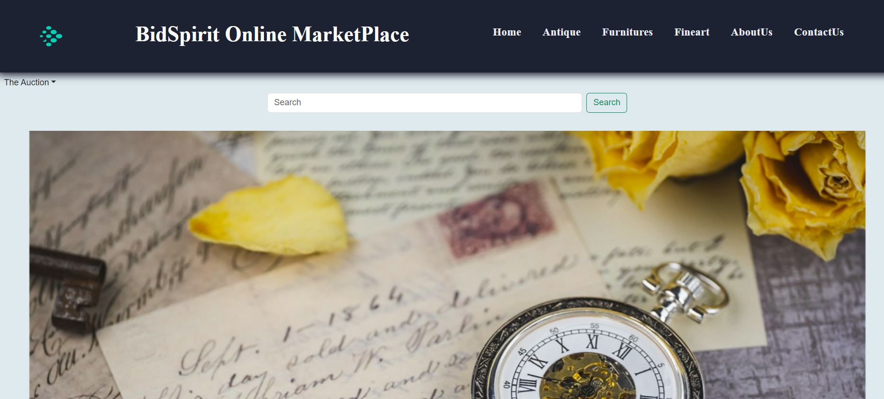

**Navigation bar:**

a) Description:

- This section will always be on top of all pages of the website.

- From here users can easily jump into any categories at any time or return to the homepage by clicking on the name of the elements in the menu which they are interested in.

- Clicking on the logo or home icon will take you to the homepage.

- Clicking on the links will direct you to the articles you want to read.

b) Screenshot:



**Blog:**

a) Description:

Welcome to [Blog Name], a place to share and explore famous collectibles from around the world. Our blog is dedicated to those who are passionate about and love rare art pieces, ranging from antiques, paintings, to sculptures and exquisite handcrafted items. Here, you'll find detailed information about the history, origin, and value of each piece, as well as stories about the collectors and the genius artists who created them. Join us on a journey to discover this colorful and inspiring world of art!"

b) Screenshot:

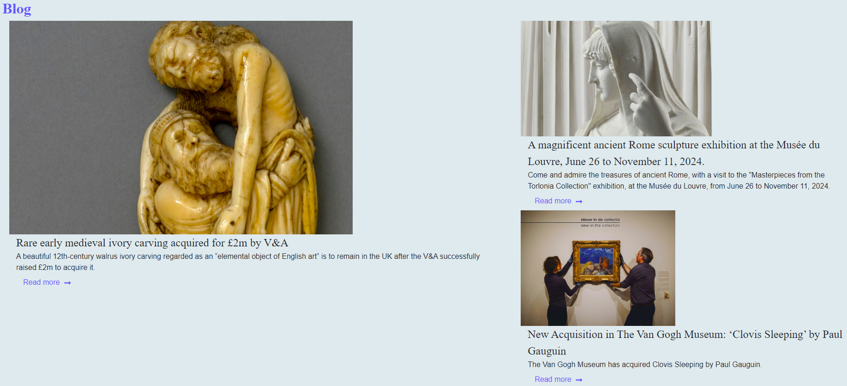

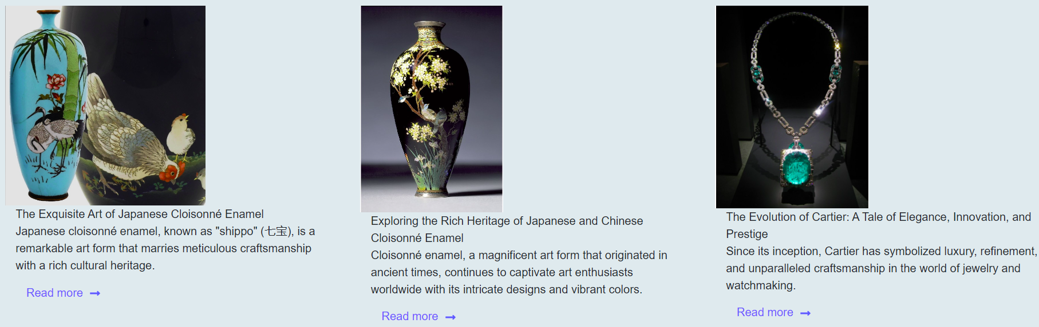

**Footer:**

a) Description:

The footer is where you can find important links and our contact information. Here, we provide quick links to the main pages of the website, such as 'About Us' and 'Contact Us'. You can also connect with us on social media platforms like Facebook, YouTube, and Instagram. Don't forget to subscribe to our newsletter to stay updated with the latest articles and events. If you have any questions or feedback, please contact us via email or phone number provided in this section.

b) Screenshot:

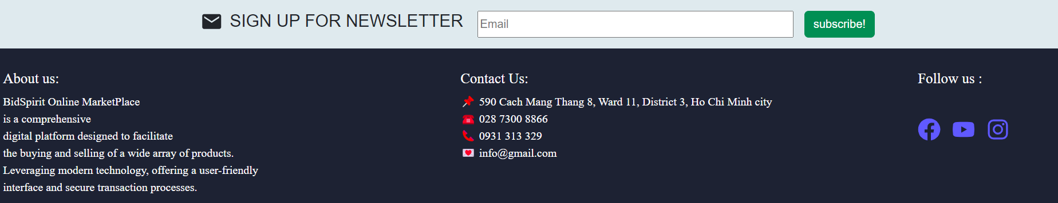

**Antique:**

a) Description:

The antique catalog on [Website Name] is a unique collection of rare and historically valuable artifacts from around the world. Here, you can explore items from various eras and cultures. Each artifact is described in detail regarding its origin and age, giving you a deep insight into the past. Whether you're a passionate collector or simply a history enthusiast, our antique catalog is sure to provide you with fascinating and enriching experiences.

b) Screenshot:

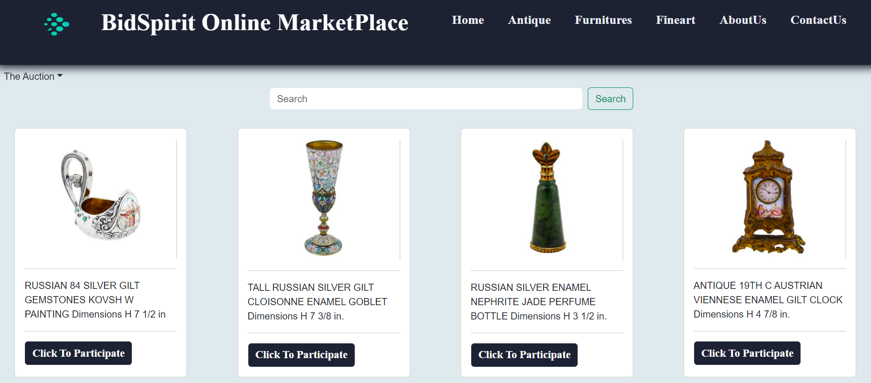

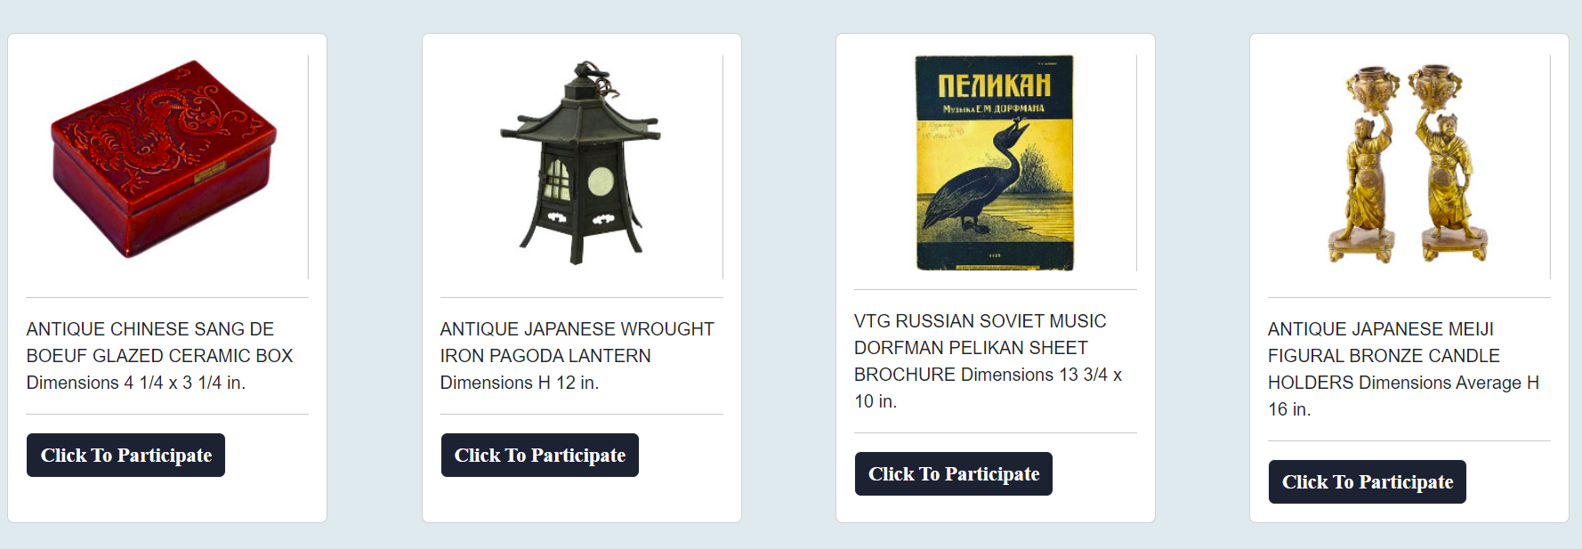

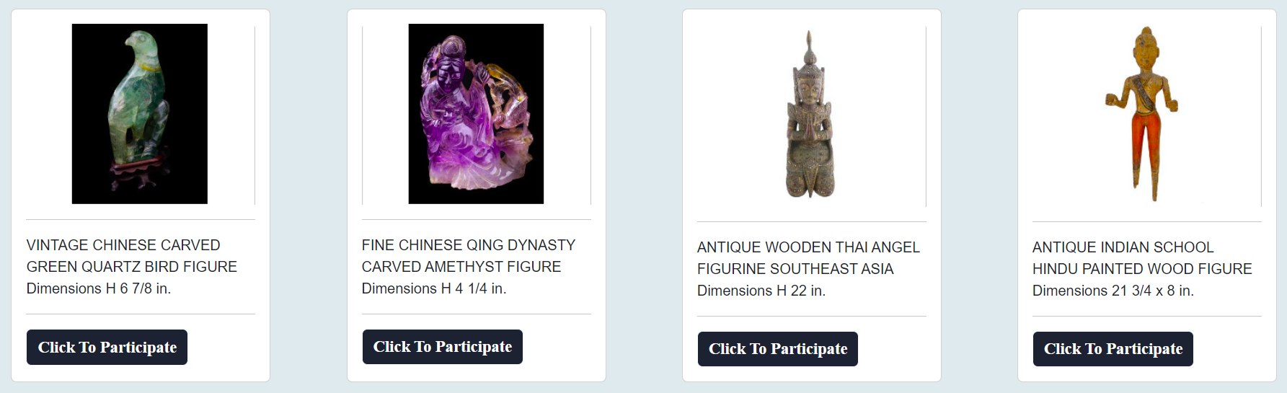

**Detail Antique:**

a) Description:

Welcome to the product introduction section on [Website Name]. Here, we provide detailed information about each product, including descriptions of design, materials, dimensions, and historical value, to give you a deeper and more comprehensive understanding.

b) Screenshot:

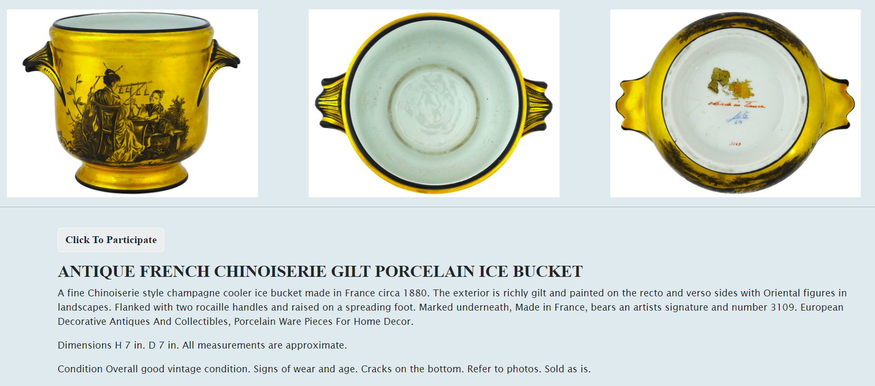

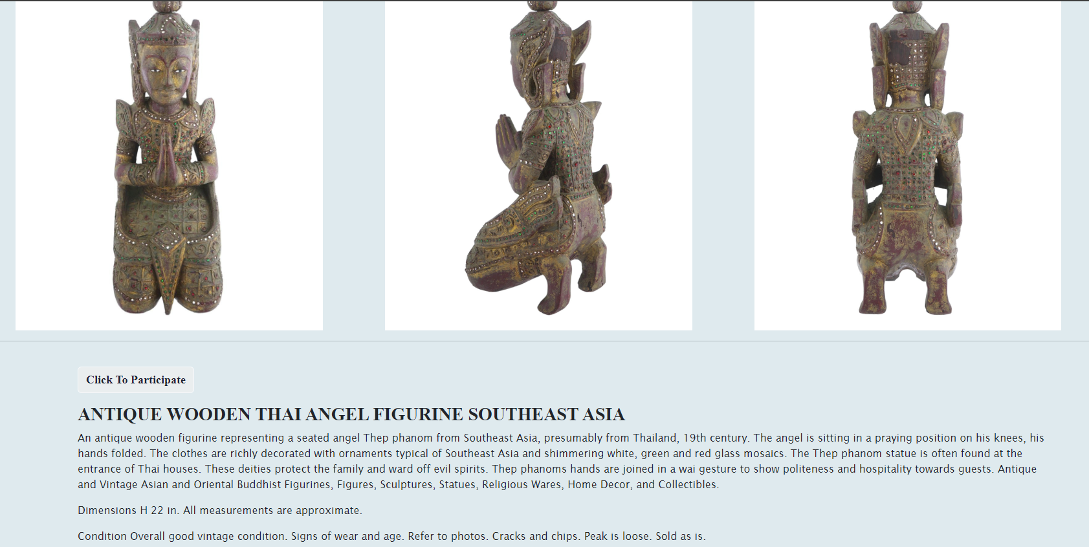

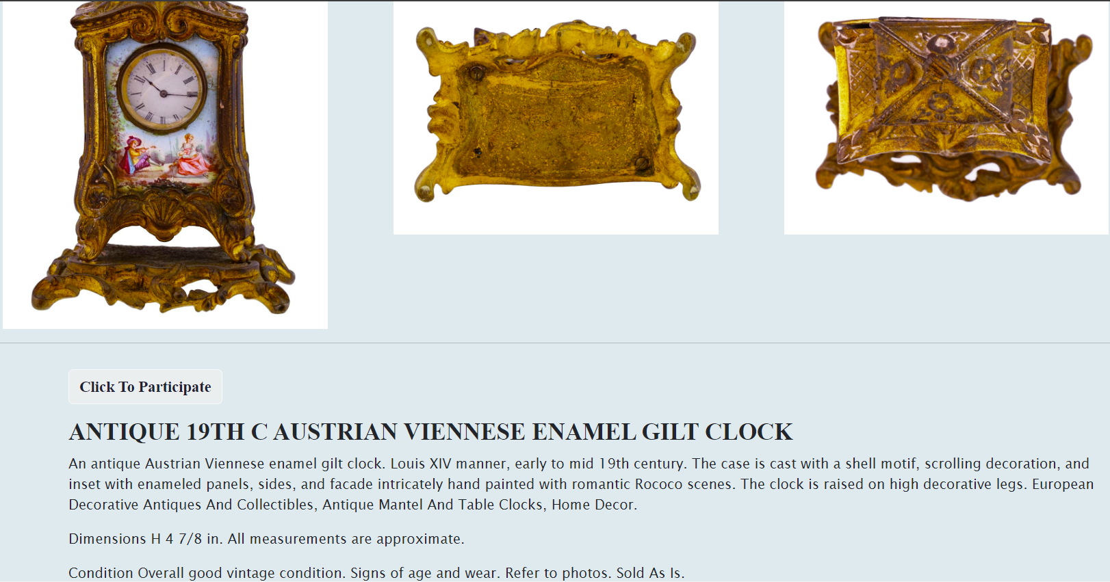

**Fineart:**

a) Description:

Welcome to the section on famous artworks from around the world on [Website Name]. Here, we proudly present masterpieces that have had a profound impact and are admired globally. These paintings not only showcase the exceptional talent of the artists but also carry rich stories, historical contexts, and deep meanings.

In our collection, you will discover works by great artists such as Leonardo da Vinci, Vincent van Gogh, Pablo Picasso, and many others. Each painting is accompanied by detailed information about its origin, artistic style, and the elements that contribute to its greatness. Join us in exploring the world of famous artworks, where each painting tells a unique story and offers you an exceptional art experience.

b) Screenshot:

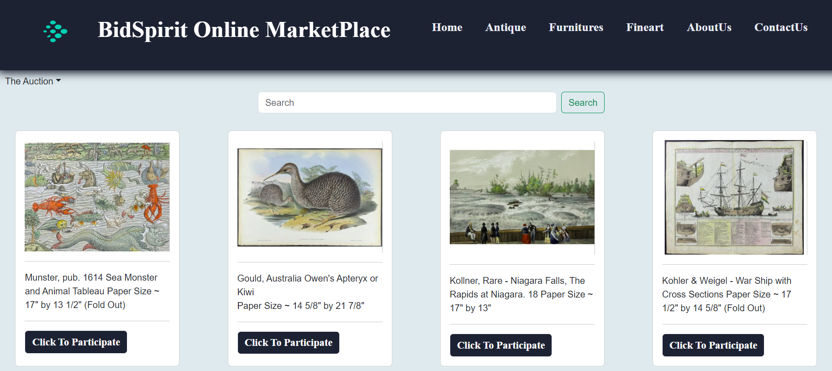

**Detail Fineart:**

a) Description:

We provide detailed information about outstanding artworks to help you better understand each piece and its context. The details about the artwork include: The official title of the artwork, and specifications about the size and material of the piece.

b) Screenshot:

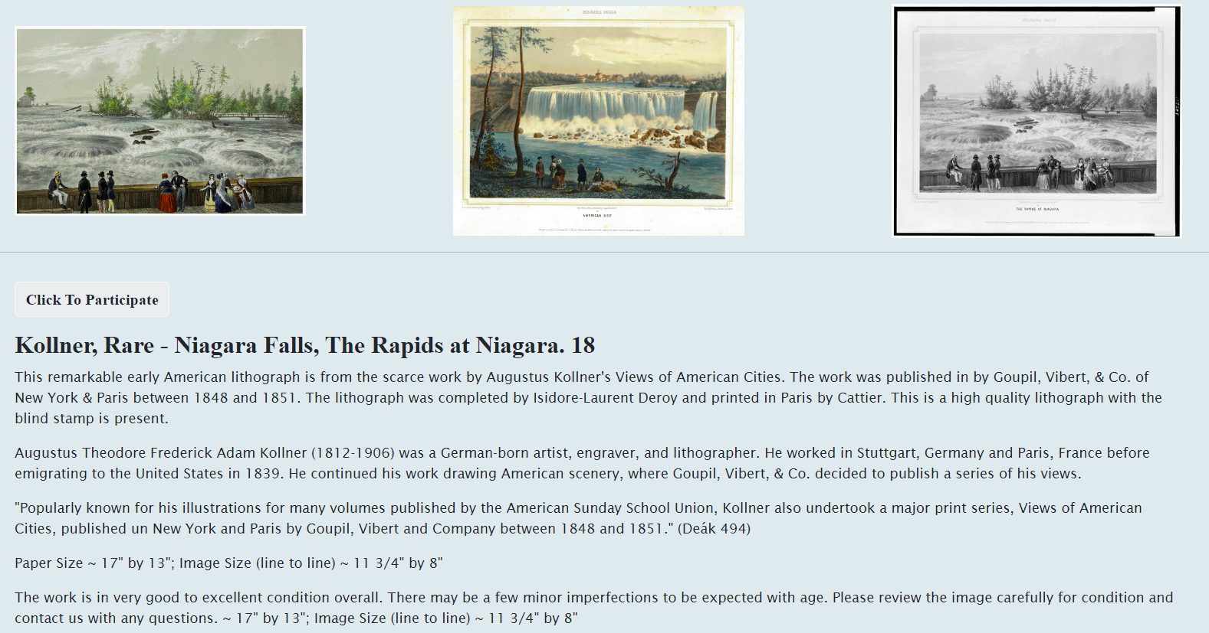

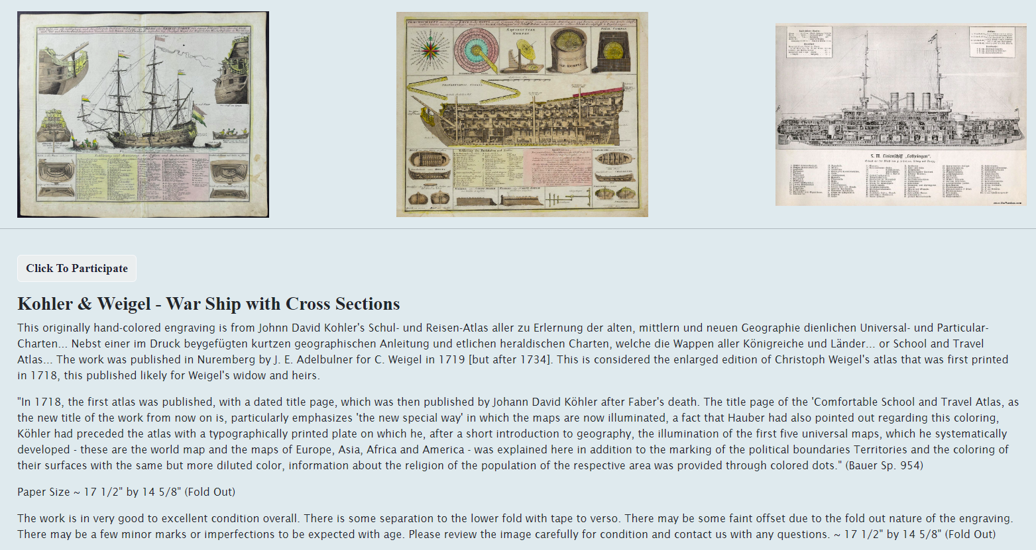

**Furniture:**

a) Description:

Welcome to [Website Name], your ideal destination for all your furniture needs. We specialize in offering a diverse range of high-quality furniture products, from elegant decorative items to complete design solutions for your living and working spaces.

Our product categories include:

Sofas and Chairs: A variety of sofas and chairs in modern, classic, and traditional styles, providing both comfort and beauty for your living room.

Dining Tables and Chairs: Dining table and chair sets with diverse designs, suitable for any style and space size.

b) Screenshot:

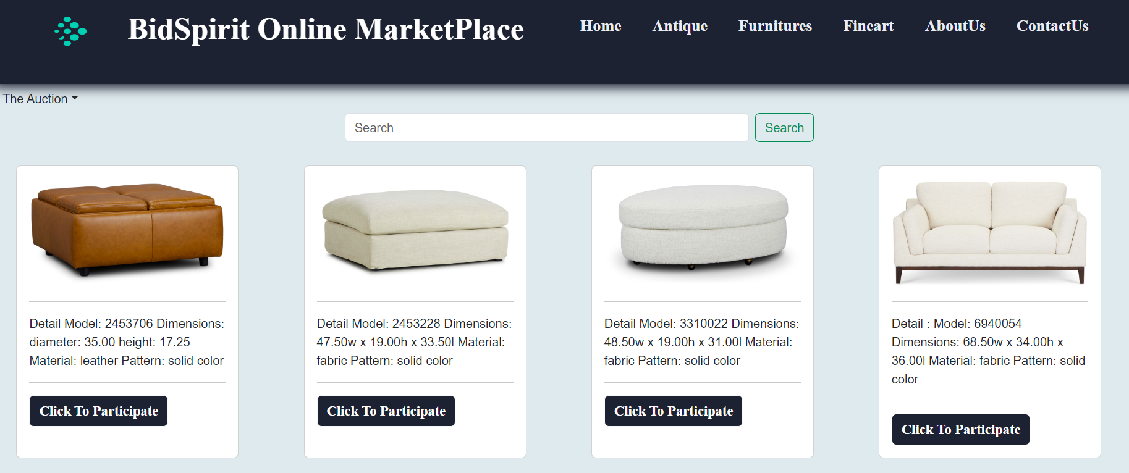

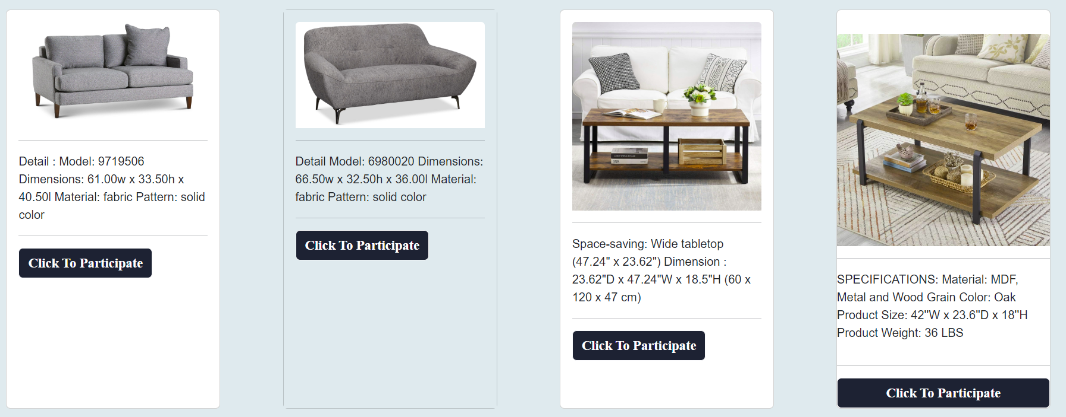

**Detail Furniture:**

a) Description:

we provide detailed information about each piece of furniture to help you make the most accurate and suitable choice for your space. Here are the key elements you will find in the details of each product:

Product Description: A detailed analysis of the design, features, and functionality of the item. We provide information on how the product can enhance your living space and its standout characteristics.

Materials and Craftsmanship: Information about the materials used and the craftsmanship techniques. You will learn about the type of wood, fabric, or other materials used, and the techniques applied to create the product.

Dimensions and Weight: Specifications about the size and weight of the product to ensure it will fit and be suitable for your space.

Images: A collection of high-quality images of the product from various angles, giving you a clear and visual understanding of the item."

b) Screenshot:

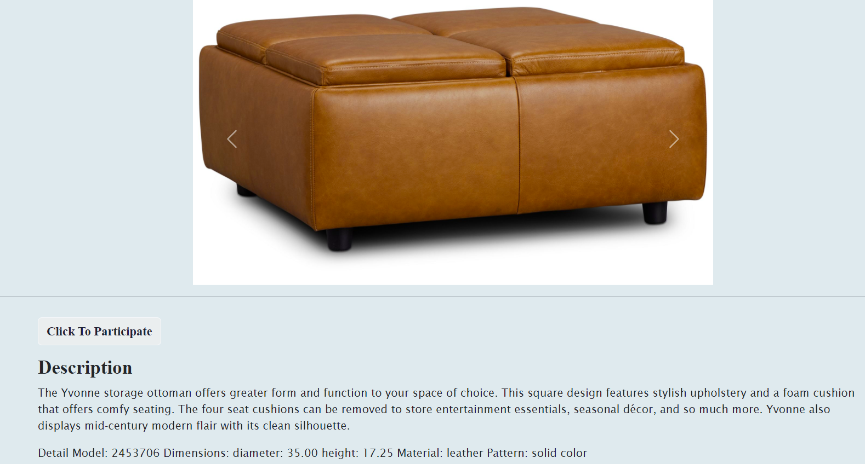

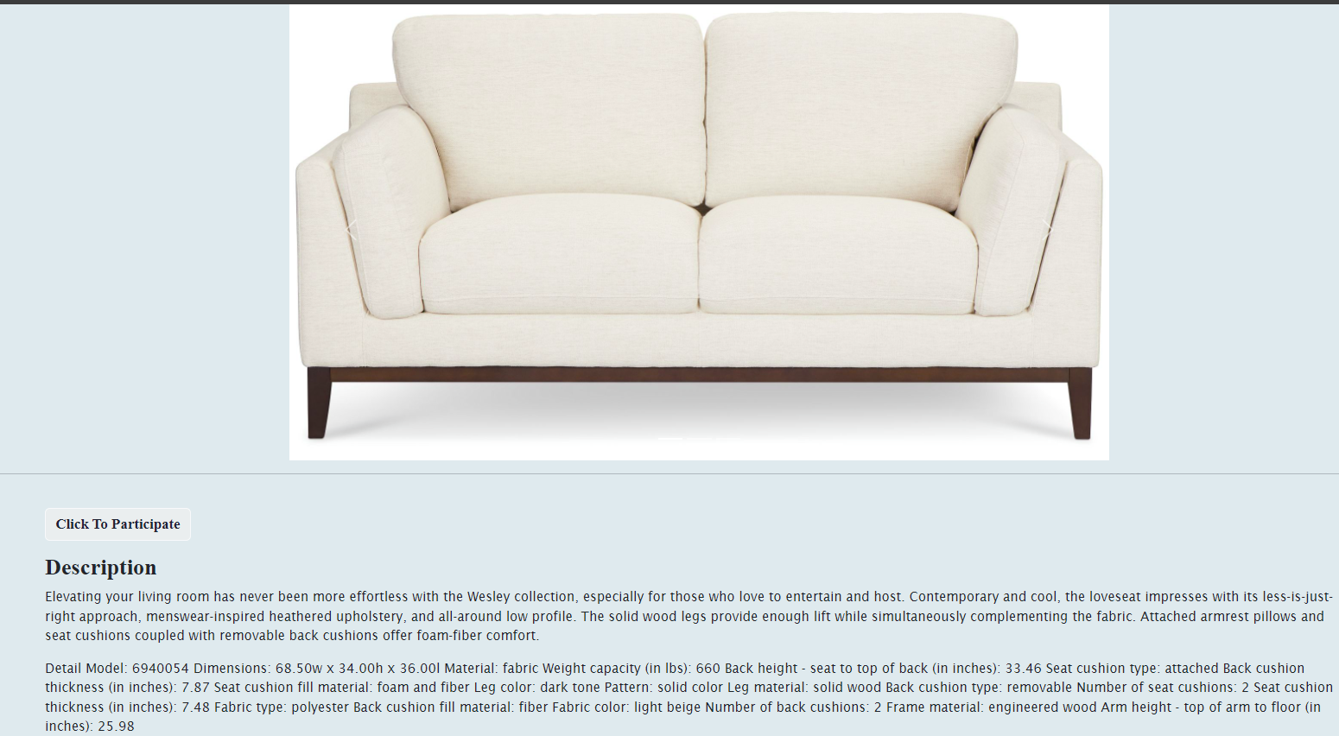

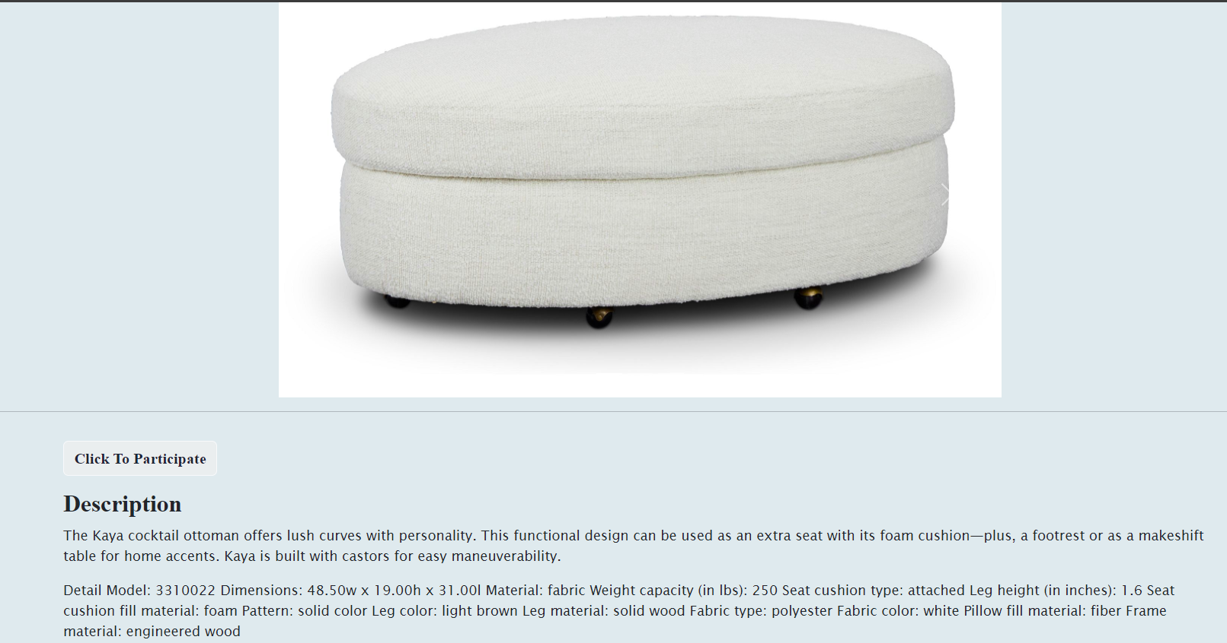

**About us:**

a) Description:

This is the introduction to the team members and an overview of our website.

b) Screenshot:

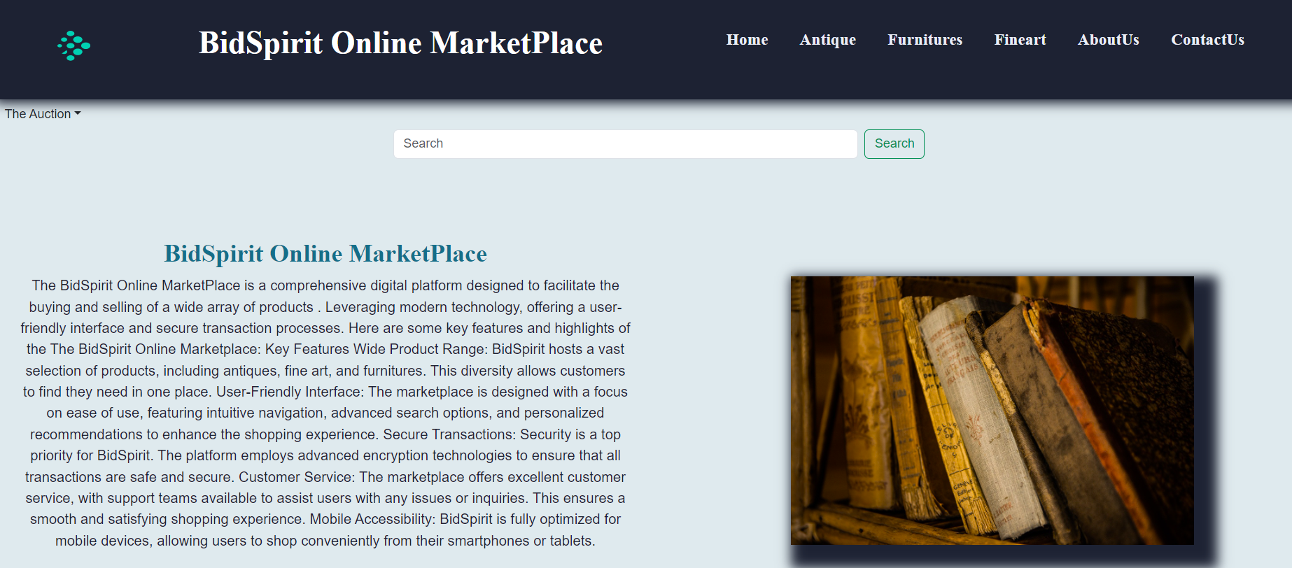

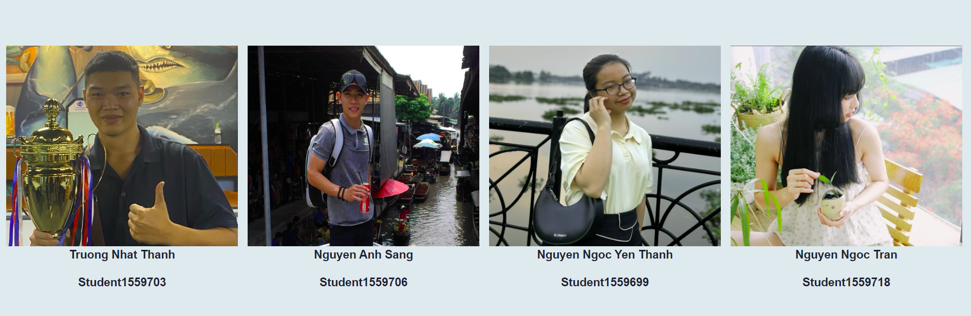

**Contact us:**

a) Description:

This page also provides google maps company addresses for you to

easily move to. Besides, you can email us directly by

clicking "Email".

If you have any questions or feedback, please contact us via email or phone number provided in this section.

We are very happy to receive your mail.

b) Screenshot:

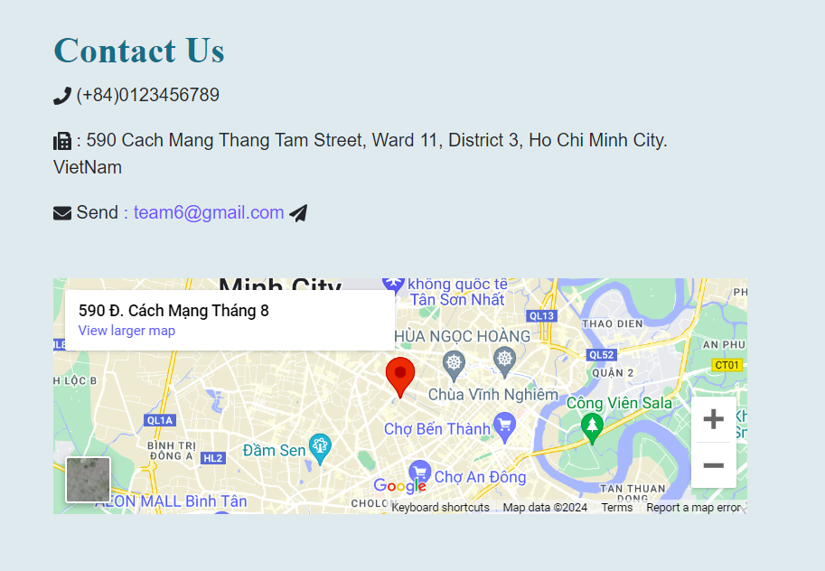

**TASK SHEET REVIEW 3**

|  |  |  |  |  |  |  |  |
| --- | --- | --- | --- | --- | --- | --- | --- |
| **Project Ref. No.:**  **eP/Advertisement** **Portal Management** **System/01** | | **Project Title:** | **Activity Plan** **Prepared** **By:** | **Date of Preparation of Activity Plan:** | | | |
| **Sr.No.** | **Task** | **Actual Start** **Date** | **Actual** **Days** | **Team** **Mate** **Names** | **Status** |
| 1 | Home page | *BidSpirit Online MarketPlace* | Sang | 01/07/24 | 3 | Ms.Tran  Ms Thanh | Completed |
| 2 | Blog | 01/07/24 | 3 | Mr.Sang | Completed |
| 3 | Footer | 01/07/24 | 2 | Mr.Thanh | Completed |
| 4 | Antique | 05/07/24 | 5 | Ms.Tran | Completed |
| 5 | Furniture | 05/07/24 | 6 | Mr.Sang | Completed |
| 6 | Fineart | 05/07/24 | 6 | Ms Thanh | Completed |
| 7 | About us | 05/07/24 | 3 | Mr.Thanh | Completed |
| 8 | Contact us | 05/07/24 | 3 | Mr.Thanh | Completed |
| 9 | Login  Register | 10/07/24 | 2 | Ms.Tran | Completed |

|  |  |
| --- | --- |
| **Date:** | |
| Signature of Instructor:  **Ms. Le Mong Thuy** | Signature of Team Leader:  **Nguyen Anh Sang** |